Map Coloring
In mathematics, the famous problem was coloring adjacent planar regions. Two adjacent regions cannot have the same color no matter whatever color we choose. Two regions which share some boundary line are considered adjacent to each other. In the following map, the region is shown by some numerical names.
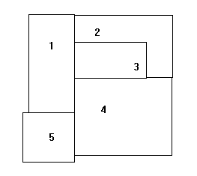
The above numerical name shows which regions are adjacent. Now we are going to consider the following graph:
